Answer 1)

Please add ‘Upgrade’ to pricing-new2.html as below

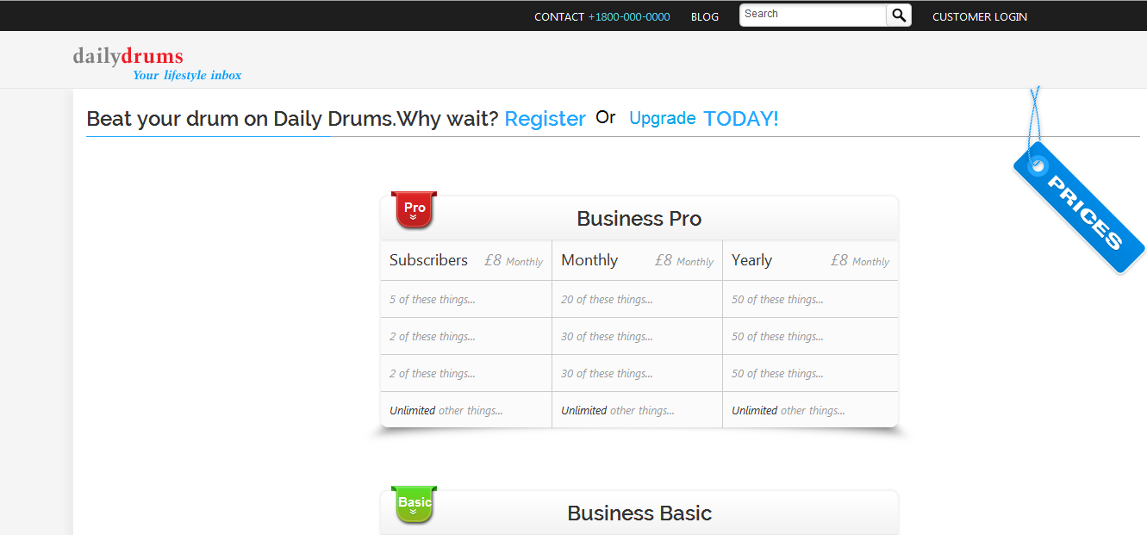

The flow should be

For Register-

-> pricing-new2.html

-> business-login.html

->business-login-proceed-basic.html

-> business-signup.html

->Process_order.html

For Upgrade / already registered user–

-> business-login.html

->business-login-proceed-basic.html

->Process_upgrade_order.html ( Get credit card details from database)

Answer 2)

Change Area-

Pull upto 10 results as the characters are entered

